LAB 1

Answer the following questions

Q#01: Write down the importance of Applied Physics in daily life. Answer should be short and Concise.
Ans: Applied physics plays a crucial role in daily life by advancing technologies that power modern Conveniences, from smartphones and medical devices to transportation systems, and renewable energy resources. It enables innovations that improve, efficiency, safety, and quality of life, making it indispensable in solving real world problems and driving societal progress.

Q#2: Why color is used in resistors?
Ans: Color coding is used in resistors to indicate their resistance value, tolerance and sometimes temperature coefficient.

No 03: If the voltage and resistors are increased in any circuit the current will be increased? Yes, or No. If yes, then why? If no, then why?
Ans: No increasing voltage and resistance in circuit does not necessarily increase current. It depends on the relationship between voltage, resistance, and current, governed by Ohm's law.

Task-01: Design the following circuits on Multisim
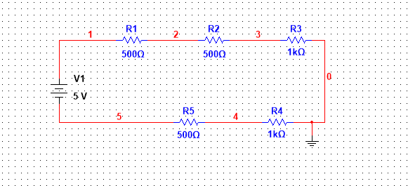

Task-02: Design the following circuits on Multisim
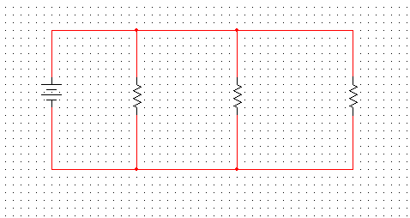
Lab 2
Worksheet
DC Circuits
As you work through the steps in the lab procedure, record your experimental values and the
Results on this worksheet. Use the exact values you record for your data to make later calculations.
Procedure A: Reading the color code of unknown resistors.
Complete the data table-1 below
Table-1
Resistor | Band 1 |  | Band 2 |  | Band 3 |  | Resistance
Resistor | Color | Value | Color | Value | Color | Value
1 | Blue | 6 | Violet | 7 | Black | 0 | 67 ohm
2 | Green | 5 | Orange | 3 | Brown | 1 | 53 *10¹=530 ohm
3 | Brown | 1 | Black | 0 | Red | 2 | 10*10² =1kOhm
4 | Brown | 1 | Red | 2 | Orange | 3 | 12 * 10³=12kOhm
5 | Blue | 6 | Black | 0 | Red | 7 | 60 * 10²=6kOhm

Table-02
Write down actual and nominal value of resistor(s) and fill the following table.
Resistors | R1 | R2 | R3
R (Nominal) | 67 Ohm | 530 Ohm | 1k Ohm
R (Actual) | 70 Ohm | 519.2 Ohm | 992 ohm

Table 3
Trial | Voltage(V) | Current(I)
1 | 5V | 0.05A
2. | 6V | 0.06A
3. | 7V | 0.07A
4. | 8V | 0.08A
5. | 9V | 0.09A

Attach graph Current VS Voltage (Make graph in MS Excel)
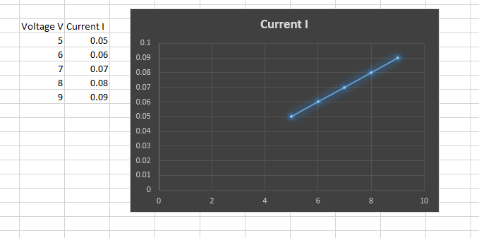

Answer the following questions.

Q#1: Ohm's law will generate which type of graph?
Ans: Ohm's Law generates a straight-line graph.

Qno-02: Why we study Applied Physics?
Ans: Applied Physics bridges theory and real-world applications, empowering us to unravel the universe's secrets and create innovative technologies.

Q03: What are the applications of Ohm's Law in real life?

Ans:
1. Conventional Domestic Fans: We control fan speed by adjusting the resistance using a regulator.

2. Electric Heaters: Ohm's Law helps calculate the power supplied to heaters.

3. Electric Kettles and Irons: The resistors in these appliances determine heat output.

4. Design of Electric Devices: Ohm's Law guides resistance selection for specific currents.

5. Fuse Design: Fuses limit current flow and use Ohm's Law for resistor selection.

6. Mobile and Laptop Chargers: Ohm's Law governs their DC power.

Q#4. Find the resistance of the following resistors using color coding scheme.
SNO | Resistor | Value | Range
 | 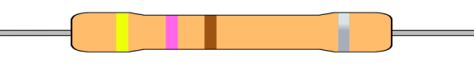 | 47 Ohm | 42.3 ohm to 51.7 ohm
 |  | 7.6k ohm | 7.2k ohm to 7.9k ohm
 |  | 2.7 Mega Ohm | 2.6 Mega Ohm to 2.8Mega Ohm
 | 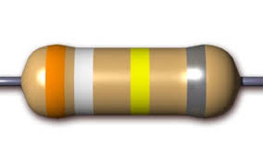 | 390K Ohm | 386KOhm to 393koOhm
Lab 3
Solve the below series circuit. To find unknown quantities as mentioned in worksheet. Choose the values of resistors of your own choice.

Voltages Through Multisim:
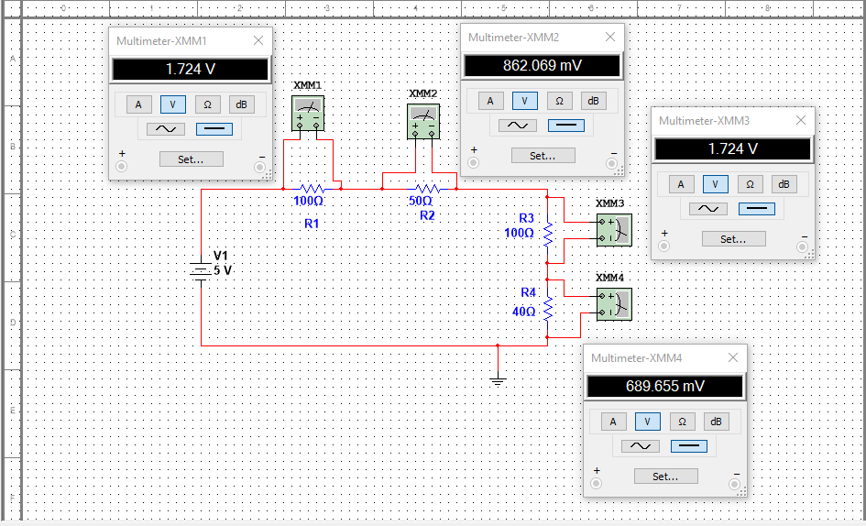

Current through Multisim:
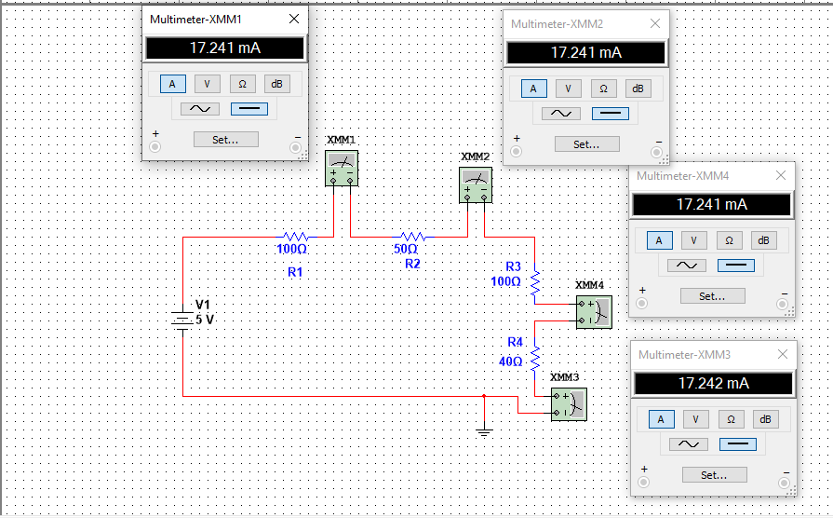

Procedure: Determining Equivalent Resistance-Series Arrangement
- Connect the two resistors in a series arrangement.
- Supply 5V to the circuit
- Find the values of four resistors
- Find the voltage and current across R1, R2, R3, and R4

Worksheet
Table 1
Resistors | R1 | R2 | R3 | R4
R (Nominal) | 100 ohm | 50 ohm | 100 ohm | 40 ohm
R (Actual) | 92 ohm | 59 ohm | 102 ohm | 38 ohm

Table 2
Values | I | V₁ | V₂ | V₃ | V4
Calculated
Measured | 17.241mA | 1.724V | 862.069mV | 1.724V | 689.655mV

Lab Exercise:
Solve any 2 examples from textbook on A4 size blank papers, to be attached with the lab handout and simulate using Multi-sim. The results and circuit snapshots should be attached with the lab handout.

